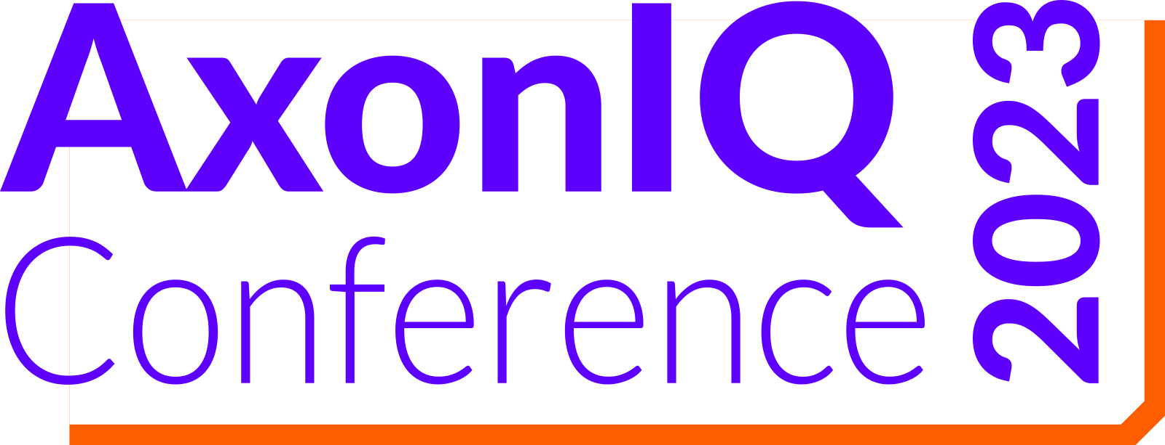

To: [Manager’s name]

From: [Your name]

Re: Attending AxonIQ Conference 2023 in Amsterdam

Dear [Manager],

I’m requesting approval to attend AxonIQ Conference 2023, the conference for the event-driven community, taking place in Amsterdam on September 28, 2023. It is an amazing opportunity for me to boost my skills, connect with industry experts, and stay on top of the latest software development trends in our space.

The conference is a full-day of educational sessions, two conference tracks, and access to industry experts. I’ll have many opportunities to gain value through:

- A full schedule with a not-to-miss keynote address delivered by the Spring Developer Advocate and Java Champion Josh Long.
- Best practices from customers who utilize Axon Framework and Axon Server to face event sourcing challenges.
- Opportunities to network with software developers, architects, and tech leads from around the world.
- Learn from the AxonIQ engineering team about the product roadmap, including future product enhancements.

[Optional - insert your projects below]
Additionally, I believe that my attendance at AxonIQ Conference 2023 will help advance the following projects:
- [Insert project one]
- [Insert project two]

When I get back from the AxonIQ Conference 2023, I will share key learnings with the team. Thank you for considering this request, and I look forward to your reply.

Best regards,

[Your name]
[Your title]

